May 21, 2014

In new exhibit of after-hours gay clubs, local historian unearths the city's LGBT legacy

"It's a Pittsburgh history of gayness; you just can't separate the two."
By Charlie Deitch

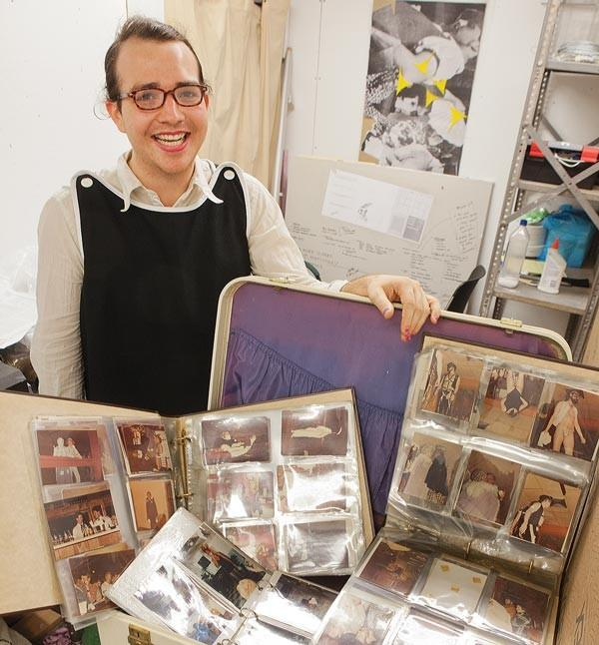
Photo by Heather Mull
Harrison Apple, of the Pittsburgh Queer History Project, with some of the items that will be part of his upcoming exhibit, Lucky After Dark, an archival look at the city's earliest after-hours gay social clubs

Lucky after Dark: Gay and Lesbian Nightlife in Pittsburgh 1960-1990.
To get a sense of the type of archeology that Harrison Apple is involved in, think Indiana Jones in the opening scene of Raiders of the Lost Ark. Now, replace the booby-trapped cave with the remnants of a dark, abandoned after-hours club in East Liberty ... and replace the coveted golden idol resting on a pedestal with a DJ booth full of old records, cigarette packs and condoms.
Apple is a graduate of Carnegie Mellon, artist-in-residence at CMU's Center for the Arts in Society and a public historian. For the past two years, he's been engaged in "queer archeology," studying gay social life in Pittsburgh between the 1960s and early 1990s. Along with his adviser, CMU's Tim Haggerty, he developed the Pittsburgh Queer History Project, an oral-history and archival project focused on the local LGBT community.
Apple's work took a groundbreaking turn in 2012, when he was given the chance by new building owners to "excavate" a former gay after-hours club at 6119 Penn Ave.
"I went to the back of the building and walked up two flights of stairs and there was a big black door with a sliding eye peephole," Apple recalls.
"They opened the door and it was like a time capsule of an after-hours joint. There were drinks on the bar and there was oil in the kitchen and rotten juice and soda everywhere. There were tinfoil stars and a DJ booth filled with empty CD cases and records and Newports and condoms and whatever."
Judging from membership cards he found on the site, the venue was known as "Upscale Private Night Club." But if the name itself was a blank slate, Apple saw the club as a trove of information.
"I brought in my plastic gloves and respirator and I bagged and tagged everything," he says. "I basically knew how many cigarettes and condoms were in the space. But we also found membership lists and cards and police reports and all these things that talked about what this space really was, both legally and socially."
And that was just the beginning. In a space between a stage and a concrete wall, Apple's boyfriend found an old wallet that had been there for probably more than two decades. Inside it was a membership card for a place called the Travelers Club.
"I did research and found that the Travelers was a gay after-hours club that was run by a guy named Lucky," Apple says. "Lucky not only ran that club, but two clubs before that and a bar. It showed that gay bars in Pittsburgh didn't just appear out of vice and ether."
That discovery led Apple to delve into the history of the city's gay after-hours clubs, the people who orbited around them, and their significance in shaping the city's present-day LGBT community. Some of the research and material he recovered will be part of a month-long exhibit entitled Lucky After Dark at Future Tenant. The show, the gallery promises in a statement, "challenges existing interpretations and assumptions about the development of an LGBT culture in Pittsburgh."
The exhibit will focus mainly on material from the three clubs operated by Robert "Lucky" Johns between the 1960s and early 1990s: the Transportation Club, the House of Tilden and the Travelers.
By focusing on those three clubs, Apple says he was able to document that Pittsburgh's LGBT community evolved much differently than those in larger cities.
"This is not a story of New York, where people come there from their hometown and use sexual identity to meet people in a new city," Apple says. "This is a place where your sexuality is operating amongst family relationships, ethnic relationships and neighborhood relationships. All of these things are very closely intertwined, and if you're going to do anything in this city, it's going to involve your family at some point.
"What we're trying to do is to take a history that's not just a gay history, but it's a Pittsburgh history. It's a Pittsburgh history of gayness; you just can't separate the two."
Haggerty, who came to the city in the late 1980s, agrees. Haggerty says that during the period Apple is studying, Pittsburgh was a city facing economic decline and out-migration. Many in the LGBT community were leaving Pittsburgh for larger cities, where they found gay enclaves in places like Dupont Circle, in Washington D.C., and The Castro, in San Francisco.
"But the people in this history stay here," Haggerty says. "It provided a new wrinkle in gender-identity politics: You not only had to negotiate your gay identity, but you also had to negotiate your familial identity. For Lucky, the two things worked hand-in-hand. He had these family connections in the world of private clubs and liquor licenses, and he used them to open up these gay social clubs." And that, he says, "became the real engine for the community — which, unlike other large cities, was spread out all over Pittsburgh."
Apple says this exhibit is not the culmination of his research, but just a beginning. Lucky's clubs, he and Haggerty acknowledge, offer a narrative that focuses largely on white, gay men. But they say their research should open up other lines of inquiry, focusing on a range of issues encompassing race and gender.
Apple says Lucky's clubs weren't the first in the city, but they were among the earliest to be owned by a gay proprietor. The clubs that previously made up the scene, he says, were there strictly to make money: "[M]aybe you could find a trick or two, but you don't talk, you don't touch, the drinks were watered down, there's no music and there's certainly no dancing."
The new clubs weren't being run as public trusts, either: "Make no mistake: Profit wasn't the bottom line, it was the only line," Apple says. "But [Johns'] clubs were a little bit funkier; you could let your hairpins down. Here came someone who was a part of this burgeoning after-hours club scene. ... Did he make money? Yes. But he also cared very much for his patrons."
The clubs attracted members for all kinds of reasons. Some were just out for a good time in a place they could be uninhibited. But others used the clubs as a gathering place to talk politics. The leadership of groups like the Persad Center and the Lambda Foundation were born out of meetings at the clubs, and with support from club owners. "These clubs became the center of community organization," Haggerty says. "A lot of the people there became politically active, and when the AIDS epidemic hit, the clubs became crucial for disseminating information."
The clubs themselves could become political causes. In 1988, East Liberty's Travelers club closed after a Valentine's Day raid by state police, who cited it for serving alcohol to minors. Patrons accused police of being abusive and shouting gay slurs; protests ensued, and the club asked a federal judge to bar police from entering the club again. "The purpose of this search was to close down a club catering to homosexuals and to chill and deter the patrons from associating with other homosexuals," their lawsuit alleged, according to a 1988 Pittsburgh Press account. The judge ultimately rejected the suit.
A lot of the material in the exhibit will come from the proprietor himself, who could not be reached for comment. "Lucky was very happy with a camera," Apple explains. "He liked everyone to have their picture taken in the club, which is kind of strange because this is obviously a world going on behind closed doors."
Identifying the subjects in as many pictures as possible was a key part of the curatorial process. The photos — some of which are on display at www.pittsburghqueerhistory.com — will be used in the exhibit and displayed from a slide projector, just as they were in the clubs themselves. Apple and Haggerty hosted identification sessions with former customers and club employees.
One person who attended those sessions was Douglas Rehrer, a former bartender at area clubs who today works at CMU. Rehrer says he began to work in the clubs while in grad school in the late 1980s, because "my work-study had fallen through." Rehrer says that Apple's research into the era is "extremely important, not just because I was part of it, but so future generations know what it was like, because it was a different world back then."
Rehrer says the photo-identification sessions were both fondly and painfully nostalgic. "It's bittersweet," he says, "to see someone [like] your best friend pop up on that screen, and they're no longer here. But this is a great project because our memories — good and bad — are all we have."

