Supplementary Materials for

Population-Specific Neuromodulation Prolongs Therapeutic Benefits of Deep Brain Stimulation

Authors: Teresa A. Spix^{1,3}, Shruti Nanivadekar^{3,4,5}, Noelle Toong², Irene M. Kaplow^{2,3}, Brian R. Isett^{1,3}, Yazel Goksen¹, Andreas R. Pfenning^{1,2,3}, Aryn H. Gittis^{1,3,}*
*Corresponding author. Email: agittis@cmu.edu

This file includes:

Materials and Methods
Figs. S1 to S6
Tables S1 to S6
Captions for Movies S1-S2
References (29-33)

Other Supplementary Materials for this manuscript include the following:

Movies S1-S2

Materials and Methods
Animals:
Experimental procedures were approved by the Carnegie Mellon University Committee for the Use and Care of Animals and in accordance to the guidelines set forth by the National Institute of Health and Society for Neuroscience Use of Animals in Neuroscience Research. Male and female heterozygous mice 4–15 weeks old on a C57BL/6J background were used for all experiments. PV-GPe neurons and Lhx6-GPe neurons were targeted using double transgenic mice from a PV-tdTmt^{+/-} ; Lhx6GFP^{+/-} mouse line. D1 neurons were targeted using a D1-Cre^{+/-} ; PV-tdTmt^{+/-} ; Lhx6GFP^{+/-} mouse line. Striatopallidal neurons were targeted using an A2A-Cre^{+/-}; PV-tdTmt^{+/-} ; Lhx6GFP^{+/-} mouse line. Animals were group housed (2–5 per group) in a 12-h/12-h light dark cycle until used for experimentation, with exception of animals used for dopamine depletion experiments (see below)

Surgical procedures and viral transfection:
As previously described (7), injections of purified double-floxed AAV2-syn-FLEX-Chronos-GFP (cell-specific activation), AAV2-syn-Chronos-GFP (pan-neuronal activation), or AAV2-hsyn-DIO-hM4D(G_{i})-mCherry (inhibitory DREADDs) produced at the University of North Carolina (Vector Core Facility) were made in D1-Cre^{+/-} (JAX: 024860); PV-tdTmt^{+/-} (JAX: 027395); Lhx6GFP^{+/-} (MMRC 000246-MU) , or A2A-Cre^{+/-} (JAX: 010687); PV-tdTmt^{+/-} ; Lhx6GFP^{+/-}, transgenic mice 4-12 weeks old. Injections were made into the subthalamic nucleus (29) or striatum (30) by methods previously described. Briefly, anesthesia was induced using ketamine (100 mg/kg) and xylazine (30 mg/kg) and maintained throughout surgery using 1.5% isoflurane. Mice were placed in a stereotaxic frame (Kopf Instruments), where the scalp was opened and bilateral holes were drilled in the skull (striatum, 2 sites: 1.35 mm anterior, ±1.9 mm lateral; 0.95 mm anterior, ±1.4 mm lateral. STN: -1.45 mm anterior, ±1.52 mm lateral from bregma). For STN injections, virus (60 nL) was injected with a Nanoject (Drummond Scientific) through a pulled glass pipet (tip diameter ∼30 µm) whose tip was positioned below the top of the brain (4.5 mm). For striatal injections, a 33-guage cannula (Plastics One, Roanoke, VA, USA) attached to a Genietouch syringe pump (Kent Scientific) was slowly lowered into position below the top of the brain (2.75 mm and 2.5 mm respectively with 2-site coordinates above), and virus was injected at the rate of 0.2 µL/min (1.75 µL and 1.25 µL respectively with 2-site coordinates above). To prevent backflow of virus, the pipet or cannula was left in the brain for 5-8 min after completion of each injection. All experiments were performed at least 4 weeks after injection to allow time for full viral expression.

Dopamine depletions:
To ensure health of the animals undergoing the dopamine depletion, weights were closely monitored and all animals weighed greater than 20 g prior to initial surgery. As previously described (7), bilateral holes were drilled over the medial forebrain bundle (−0.9 mm posterior, +/−1.12 mm lateral from bregma) for 6-OHDA injections. A 33-gauge cannula (Plastics One, Roanoke, VA, USA) attached to a syringe pump, was slowly lowered down into place (MFB: 5.1mm from top of the brain). At this point, 1 μL of 6-OHDA (5 μg/μL in 0.9%NaCl) was slowly injected into the MFB at a rate of 0.1 μL/min. The injection cannula was left in place for five additional minutes. Afterwards, the other hemisphere was injected following an identical protocol.
After all dopamine depletions, mice were placed into a recovery station. The station consisted of a new cage, soft food, chocolate pellets, shallow water dish and half of the cage was placed on a heating pad. In addition, a daily injection of saline (0.9% NaCl; intraperitoneally) was used to curb dehydration, and weight was closely monitored to ensure the greatest level of health for each animal.
A criteria of less than 27% remaining TH across the hemispheres was used for animals in behavior experiments (left hemispheres: 4.67 ± 0.07%; right hemispheres: 8.18 ± 0.11%.

Electrical stimulator fabrication and implantation:
Electrodes for in vivo deep brain stimulation were fabricated as previously described (19), with the following modifications. Briefly, each of the two six-lead bipolar stimulating electrodes was constructed by twisting together 76.2µm coated wires, heating the wires to slightly fuse the coating, and then cutting the fused end at an angle. The six twisted ends therefore formed three electrode pairs at various depths. The six untwisted ends were then stripped using a razor blade and fit into female Millimax connectors. Prior to surgical implantation, electrodes were tested for short circuits and the bipolar pulse trains of desired current amplitude were tested at each contact on both electrodes.
For dopamine depleted animals used for behavioral experiments, during the depletion surgery described previously, bilateral holes were also drilled over the GPi/GPe border for implantation of stimulating electrodes ( -0.96 mm posterior, +/- 1.75 mm lateral from bregma, 4.61 mm from the top of the brain). The 2 stimulating electrodes were simultaneously and slowly lowered into position by affixing them to a single connector and secured to the skull with Metabond.

Neuromodulation (brain slices):
For each analysis described throughout, values were measured from average responses of 5 consecutive sweeps and data are expressed as mean ± standard deviation in the text (unless otherwise indicated). Figure legends indicate statistical measures represented in figures. All statistical analyses described herein were performed in IBM SPSS, version 27.
For each cell, baseline firing rate was calculated as the average firing rate over the 2 s prior to stimulation, and during stimulation, per trial. Stimulus firing rate was conducted after stimulation artifact removal; 0.07 – 0.11 ms were removed for each stimulus to subtract electrical stimulation artifacts (no subtraction necessary for optogenetic experiments). Action potentials that occurred during the stimulus window were then counted (per trial) and divided by the stimulation duration to calculate the stimulus firing rate. A modulation factor (MF) was then calculated for each trial: MF = (FR_{stim}-FR_{baseline}) / (FR_{stim}+FR_{baseline}), and these modulation factors per trial were averaged to calculate a mean modulation factor per neuron, which is plotted as a single point in figures. Paired t-tests of baseline firing rate vs. firing rate during stimulation were used to determine if a neuron was significantly modified from its baseline over multiple trials. Any neurons that were not significantly modified are noted with gray points throughout figures. Comparisons between cell-types for modulation factors in any given condition were made with a Mann Whitney U (Wilcoxon nonparametric). Electrical stimulation details are described below (see “Electrical stimulation” under Electrophysiological recordings).
Statistical analysis regarding EPSCs, IPSCs, and inhibition-excitation balance was performed using Kruskal - Wallis analysis of variance (ANOVA) nonparametric test (KW) and any differences were further investigated with a Mann-Whitney U (Wilcoxon nonparametric) pairwise comparison between cell types with a Bonferroni correction.

Electrophysiological recordings
As previously described (31), parasagittal sections (300 µm thickness) containing the GPe were prepared from brains of 5- to 14-week-old mice. Slices were prepared on a Leica VT1200 vibratome in an ice-cold HEPES cutting solution (in mM): 92 NaCl, 2.5 KCl, 1.2 NaH₂PO₄, 30 NaHCO₃, 20 HEPES, 25 glucose, 5 sodium ascorbate, 2 thiourea, 3 sodium pyruvate, 10 MgCl₂, and 0.5 CaCl₂. Slices were allowed to recover for 15 min at 33°C in a chamber filled with N-methyl-d-glucamine (NMDG)–HEPES recovery solution (in mM): 93 NMDG, 2.5 KCl, 1.2 NaH₂PO₄, 30 NaHCO₃, 20 HEPES, 25 glucose, 10 MgSO₄, 0.5 CaCl₂, 5 sodium ascorbate, 2 thiourea, and 3 sodium pyruvate. After 15 min, slices were held at room temperature for at least 1 h before recording in a holding solution that was similar to the HEPES cutting solution but with 1 mM MgCl₂ and 2 mM CaCl₂. Recordings were made at 33°C in carbogenated ACSF (in mM): 125 NaCl, 26 NaHCO₃, 1.25 NaH₂PO₄, 2.5 KCl, 12.5 glucose, 1 MgCl2, and 2 CaCl2.
Data were collected with a MultiClamp 700B amplifier (Molecular Devices) and ITC-18 analog-to-digital board (HEKA) using Igor Pro software (Wavemetrics) and custom acquisition routines (Recording Artist; Richard C. Gerkin, Phoenix, AZ). Voltage-clamp recordings were filtered at 2 kHz and digitized at 10 kHz. Recording electrodes were made from borosilicate glass (pipette resistance, 2–4 MΩ) (World Precision Instruments). Different internal solutions were used depending on the experiment. The internal solution for extracellular recordings consisted of the following (in mM): 130 KMeSO₃, 10 NaCl, 2 MgCl₂, 0.16CaCl₂, 0.5 EGTA, 10 HEPES, 2 Mg-ATP, 0.3 Na-GTP; pH 7.5. The internal solution for intracellular recordings consisted of the following (in mM): 120 CsMeSO₃, 0.5 EGTA, 10 BAPTA, 10 HEPES, 2 Mg-ATP, 0.3 Na-GTP, 5 QX-314; pH 7.3. This low chloride internal resulted in E_{Cl-} (-85mV). Electrical stimulation was delivered through a stimulus isolator (ISO-Flex) connected to a concentric bipolar electrode (FHC CBBPF75) at described stimulation amplitudes. The stimulating electrode was placed in the internal capsule fibers between the EPN and the GPe.
Extracellular recordings: For measurements of autonomous or driven firing in neurons, cell-attached recordings were used to prevent disruption of intracellular milieu. Recordings were made 2 - 3 minutes after securing a 20 – 75 MΩ seal in spontaneously firing neurons.
Intracellular recordings: For whole-cell voltage clamp recordings, cells were first clamped at -70 mV after break-in and allowed to recover for 3-8 minutes. Rs was monitored throughout the experiment, and cells with an Rs over 30 MΩ, or cells where Rs changed by more than 30% over the course of the recording were excluded. Measurements of peak EPSC amplitude within 20 ms of stimulation were then made on the first event in any given stimulus series. To measure inhibitory currents, neurons were then ramped from -70 mV to 0 mV over 5 s. Peak IPSC amplitude was calculated as described above. All synaptic response amplitudes were calculated by finding the average amplitude of evoked PSCs in five consecutive trials with an intertrial interval of 30 s unless noted otherwise.
Electrical stimulation: While extracellularly attached, electrical stimulation trains at described frequencies, durations, and stimulation amplitudes/intensities were delivered to sequentially recorded cells within 50 µm of each other. When unspecified in the text, stimulation amplitudes were 1.0 mA. For a subset of experiments, a thresholding approach was used to control for variation in tissue excitability and stimulation placement. To threshold a slice, 3 neurons were randomly challenged with 100 Hz, 1 s stimulation at varying amplitudes, while monitoring extracellular firing rate. The lowest amplitude to drive a statistically significant response over 5 trials was defined as the ‘minimum amplitude’ for that cell. The average minimum amplitude was calculated for the 3 neurons, and multipliers of this value/’stimulus intensity’ were used for subsequent paired experiments. Frequency, duration, and stimulus intensity order were identical for each neuron in an in-field pair, but pseudo-randomly varied between pairings. Pulse widths of 0.1 ms and a monophasic waveform were used throughout all in vitro electrical stimulation experiments, unless stated otherwise. A subset of experiments were performed with a biphasic stimulus and are indicated in the text and figure legend (Fig. S4). An isolated constant current bipolar stimulator (WPI) was used to deliver electrical stimuli using monophasic or biphasic square waves as indicated.
Optogenetic stimulation: Optical stimulation was delivered at 100 Hz for 1 s with a pulse-width of 1 ms for all optogenetic experiments (filtered at 470nm, delivered through the 60x objective of the rig microscope). Due to the use of a PV-tdTmt+/- ; Lhx6GFP+/- mouse line and GFP-tagged Chronos in optogenetic experiments, the presence of fluorescence in a field was insufficient to indicate successful viral transfection. A neuron in a given field was tested with 0.05 mW light power. If there was no response, laser power was incrementally raised to maximum power (1 mW), stopping when a response was observed (average across responding cells ~0.5 mW). An in-field partner neuron would then be tested at the same laser power. Pairs where neither neuron responded to 1 mW were excluded as this could be due to insufficient virus expression in the region.
Chemogenetic inhibition: While extracellularly attached, electrical stimulation was delivered as described above. After 5 sweeps of responses were collected with a 30 s intersweep interval, Clozapine N-Oxide dihydrochloride (CNO) was added to the bath. Electrical stimulation was continued with a 30s intersweep interval for a period of 10 minutes to allow for CNO effectiveness. The 5 sweeps of this collection taken after the 10 minute mark were analyzed for post-CNO results.
Drugs: NBQX disodium salt, D-APV, picrotoxin, and Clozapine N-Oxide dihydrochloride were obtained from Tocris Bioscience. All drugs were reconstituted in double-distilled water, frozen until use, and then diluted to the appropriate concentration by adding to the superfusate at the beginning of each experiment.

Behavioral experiments:
Electrode pair selection: An isolated constant current bipolar stimulator (WPI) was used to deliver electrical stimuli. The timing of stimulus delivery was controlled by TTL input from an Arduino. Mice were tethered to an electrical input cable, and optimal stimulation (electrode pair and amplitude) was determined based on the animal’s behavioral response to 100 Hz constant stimulation in the open field. As higher stimulation amplitudes are known to lead to seizures, amplitudes beginning at 65 µA were tested and then increased incrementally by 10 µA until the animal increased movement in the open field (2,500 cm² transparent open field with an opaque, smooth base), indicating a therapeutic effect.
Conventional and burst DBS parameters: Our DBS settings were modeled after conventional DBS settings in humans and rat models (32). During ‘burst stimulation’, animals received stimulation at 175 Hz (200 ms duration), with an average amplitude of 110 μA and pulse width of 60 μs. Stimulation for 175 Hz bursts was delivered as 35 biphasic, bipolar pulses in a 200 ms period per second of stimulation (200 ms of stimulation followed by an 800 ms pause). Schor et al. previously showed the therapeutic efficacy of DBS is related to the total electronic energy delivered during stimulation (19). Therefore during ‘conventional DBS’, we kept this value constant by adjusting the frequency and current amplitude values during stimulation such that animals received continuous bipolar, biphasic stimulation at 100 Hz, with an average amplitude of 109 μA and pulse width of 60 μs. However, to ensure that the different therapeutic duration observed following ‘burst’ vs. ‘conventional’ DBS were not due to difference in stimulation frequency, in 2/8 mice, conventional DBS was delivered at 175 Hz instead of 100 Hz. In these mice, 175 Hz ‘conventional DBS’ produced similar velocity, immobility, and therapeutic duration results as mice who received 100 Hz ‘conventional DBS’. In order to test the validity of the machine-learning model in predicting the degree of cell-type modulation and the consequent motor recovery caused by other stimulation settings, we tested 3 additional burst DBS protocols including a stimulation at 175 Hz delivered either as 1s stimulation followed by a 4s pause or 10s stimulation followed by a 40s pause; and a stimulation at 50 Hz delivered for 200 ms with an 800 ms pause.
Open field behavior: Following optimal electrode pair and amplitude selection, efficacy of each DBS stimulation protocol was assessed as follows. In a crossover design, mice were pseudorandomly assigned to either receive conventional (constant) stimulation or burst stimulation on the first day. Mice were placed in the open field and 10 minutes of baseline data were collected. Afterward, the assigned stimulation protocol was delivered for 30 minutes. Post-stimulation data was then collected for an additional 2-3 hours to monitor potential persistent motor effects. Mice were tested on alternate stimulation protocols on successive days, and all mice were tested on both stimulation protocols for comparative analysis.
Behavior analysis: Following each behavior experiment, video-tracking software (Noldus Ethovision) was used to calculate immobility and average velocity. Behavioral metrics were binned in 30 s intervals. Average velocity was computed by dividing the total distance moved (in cm) by the bin duration. Percent immobility was then calculated by taking the fraction of time that the animal was ‘immobile’ within the bin. Animals were defined as ‘immobile’ when center-point velocity was less than 0.75 cm/s for 15 samples, sampled at 29.97 frames per second.
Therapeutic duration was defined as the amount of time after DBS was turned off before mice returned to pre-stimulation immobility, or >80% immobility, across 3 consecutive 10-minute intervals. Statistical analysis regarding immobility and average velocity was performed using a Wilcoxon signed-rank pairwise comparison between pre-, stim-, and 90’ post periods.

Immunohistochemistry:
Immunohistochemistry was carried out in free-floating frozen sections (30 μm). Whole brains or sliced tissue was resectioned in 30 μm slices using a freezing microtome (Microm HM 430; Thermo Scientific), blocked with 10% normal donkey serum, and permeabilized with 0.5% Triton X-100 for 1 hr.
TH immunoreactivity: Degree of dopamine denervation was assessed in all animals based on immunofluorescence against tyrosine hydroxylase.
For slice electrophysiological experiments, slices were prepared as described above. A littermate control was processed in parallel to the experimental animal, using all in vitro protocols. Shortly after electrophysiological recordings, slices from the experimental animal and littermate control were post-fixed in 4% PFA for 24 hr before being rinsed with PBS, transferred to 30% sucrose in PBS, and stored at 4°C for at least 24 hr prior to sectioning.
For behavioral experiments, a littermate control was also processed in parallel to the experimental animal. Shortly after the final behavior recordings, mice were sacrificed and perfused transcardially with phosphate buffered saline (PBS), followed by 4% paraformaldehyde (PFA) in PBS. Brains were retrieved, fixed in 4% PFA for 24 hr before being placed in a 30% sucrose solution.
Sections were prepared as described above, and primary antibody incubations were performed at room temperature for 24 hr using rabbit anti-TH (1:1000; Pel-Freez). Primary antibodies were detected with Alexa Fluor 647-conjugated donkey anti-rabbit (1:500, Thermo Fisher Life Technologies), incubated for 90 min at room temperature. Tissue was then mounted and cover-slipped with gelvatol prior to imaging.
TH quantification: Epifluorescent images (10x magnification) from TH staining were taken from dorsal striatum in bilateral sagittal sections. Pixel intensity over a 75 × 75 μm area (5625 μm²) from each hemisphere was measured using the pixel intensity measuring tool in ImageJ, background fluorescence was subtracted by measuring fluorescence intensity in cortex, and then normalized to the pixel intensities measured in littermate control mice, processed and imaged in parallel.
Striatal projection imaging: Imaging of striatonigral and striatopallidal projections was completed through enhancing and imaging AAV2-syn-FLEX-Chronos-GFP which had been injected in D1-Cre^{+/-} and A2A-Cre^{+/-}; PV-tdTmt^{+/-} transgenic mice 4-12 weeks old. Animals were perfused transcardially with PBS followed by 4% PFA, and brains were fixed in 4% PFA for approximately 24 hours before being moved to 30% sucrose. Sections were prepared as described above. GFP was enhanced with chicken anti-GFP (1: 1000, Aves Laboratory) incubated for 24 h at room temperature. Sections were then incubated in AlexaFluor-488 anti-chicken (1:500, Invitrogen) for 1.5 h at room temperature. Tissue was then mounted and cover-slipped with gelvatol prior to imaging.
Cell-type quantification: Naïve PV-tdTmt^{+/-} ; Lhx6GFP^{+/-} mice were perfused transcardially with PBS followed by 4% PFA, and brains were fixed in 4% PFA for approximately 24 hours before being moved to 30% sucrose. Sections were prepared as described above. Primary antibody incubations were performed at room temperature for 24 hr using mouse anti-HuCD (1:250; Thermo Fisher Life Technologies). The primary antibody was detected with Alexa Fluor 647-conjugated donkey anti-mouse (1:500, Thermo Fisher Life Technologies), incubated for 3 hours at room temperature. Tissue was then mounted and cover-slipped with Vectashield (Vector Laboratories) prior to imaging. Cells were marked (using Adobe Photoshop) in individual channels before overlaying markers to quantify dual-labeling. This approach was used as differences in relative fluorescence between GFP and RFP channels could lead to undercounting ‘dual-labeled’ cells if only using a merged image.
Electrode placement verification: For behavioral experiments, electrode placement was verified by collecting sections as described above from slices showing evidence of the electrode track. Primary antibody incubations were performed at room temperature for 24 hr using rabbit anti-Iba1 (1:1000, Wako). Primary antibodies were detected with Alexa Fluor 647-conjugated donkey anti-rabbit (1:500, Thermo Fisher Life Technologies), incubated for 90 min at room temperature. Tissue was then mounted and cover slipped with Vectashield (Vector Laboratories) prior to imaging.

Computational Methods:
We identified putative optimal parameter values by training a machine learning model to use the log of the duration, the amplitude, and the frequency to predict the modulation factors of each cell type; evaluating the machine learning models’ predictions for different values of these parameters; and selecting parameter values for which the model predicted a high population separation index (PSI) between PV and Lhx6 neurons. We collected data by presenting 19 pairs of PV-GPe and Lhx6-GPe neurons with each of approximately 10 different burst parameter combinations. We randomly generated burst combinations from the parameters in Table S1. For 9 of the pairs, we used a new randomly generated set of parameter combinations for each neuron. For the remaining 10 pairs, we used the same set of parameter combinations for each neuron in the pair. If a cell’s baseline firing rate dropped to 0 Hz for 2 minutes in an experiment, we stopped the recording. Since we randomized generation of parameter combinations, there was overlap for some combinations in the data set, resulting in 208 unique combinations. We tried a variety of computational models to predict PV-GPe and LHX6-GPe modulation factors and evaluated the leave-one-out cross-validation performance, where a held-out “example” was all of the samples for a single combination of parameter values. We fit the regression models using the R kernlab package (33). When doing leave-one-out cross-validation, we trained the models to predict the raw modulation factors, and we calculated the Pearson and Spearman correlation coefficients between each model’s prediction on the held out set of unique parameters and that parameter set’s average modulation factor. We did not have sufficient data to have a separate held-out test set to evaluate how well the model generalizes to examples that were not used for training or model selection, so it is possible that the models overfit to our data. Gaussian process regression with a quadratic polynomial kernel, which allows for putative non-linear relationships between parameters and for intermediate values leading to higher modulation factors than extreme values, showed the strongest performance (Table S2).
We then used our selected models to identify parameter values that would be likely to improve the PSI. We did this by making predictions on thousands of artificially generated parameter value combinations (Table S3) for each model and identifying combinations that led to large predicted PSIs. We computed the predicted PSI by subtracting the predicted MF_{Lhx6} from the predicted MF_{PV}.
After obtaining these results, we performed more experiments to explore values around the predicted optimal parameter values (Table S4) to determine if such values would produce greater PSIs than the parameter values that we had previously tested. We repeated the above process of training a Gaussian process regression model for each of PV-GPe and Lhx6-GPe for the newly acquired data in addition to the previously acquired data. We then again used each model to make predictions for the parameter values from Table S3 and computed the predicted PSI. We performed more experiments for values close to these new predicted optimal parameter values as well as parameter values that were far from these optimal parameter values.

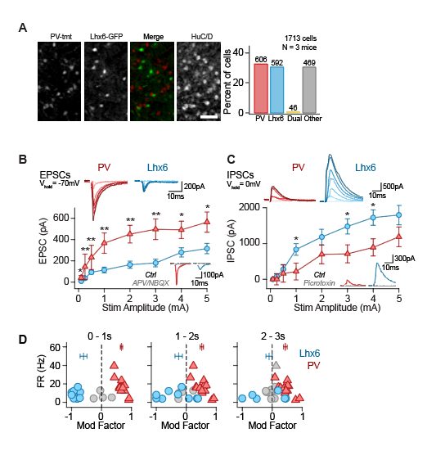

Fig. S1. Inhibitory/Excitatory imbalance results in decreasing efficacy of differential modulation over time. (A) Left: histological verification confirming low overlap of PV-GPe and Lhx6-GPe neurons in Lhx6-GFP^{+/-}; PV-tdTmt^{+/-} mice. Right: Cell count quantification of cell types in the GPe in this mouse line (PV: 34 ± 0.05%, Lhx6: 32 ± 1%, PV/Lhx6 dual-labeled: 2 ± 0.2%, HuC/D only: 32 ± 16%) (1,713 cells; 3 mice). Scale bar 20µm. (B) EPSCs evoked by stimulation at different stimulus intensities are higher in PV-GPe (red) than Lhx6-GPe (blue) neurons (KW, χ2(7) = 44.4, p< 0.00001, post-hoc pairwise Mann Whitney U (MWU), *p < 0.05, **p< 0.001; 15 pairs of neurons; 9 mice). Throughout the figure, values are medians ± sem. Top insets show typical EPSCs measured across different stimulus intensities in each cell type. Bottom insets show glutamate receptor antagonist knock-down of EPSCs (50 µM D-APV and 10 µM NBQX). (C) IPSCs evoked by stimulation at different stimulus intensities are lower in PV-GPe (red) than Lhx6-GPe (blue) neurons (KW, χ2(7)=8.45, p=0.004, post-hoc pairwise MWU, *p < 0.05; 15 pairs of neurons; 9 mice). Top insets show typical IPSCs measured across different stimulus intensities in each cell type. Bottom insets show GABA_{A} receptor antagonist knock-down of IPSCs (50 µM picrotoxin). (D) Modulation factors (averaged across 5 trials) for each neuron during the indicated time bin (14 pairs of neurons; 3 mice). Gray symbols: Neurons in which firing rate was not significantly modified from baseline (p > 0.05, paired t-test FR_{baseline} vs. FR_{stim}, Trials 1-5). Horizontal markers show average MF_{Lhx6} and MF_{PV}, error bars are sem.

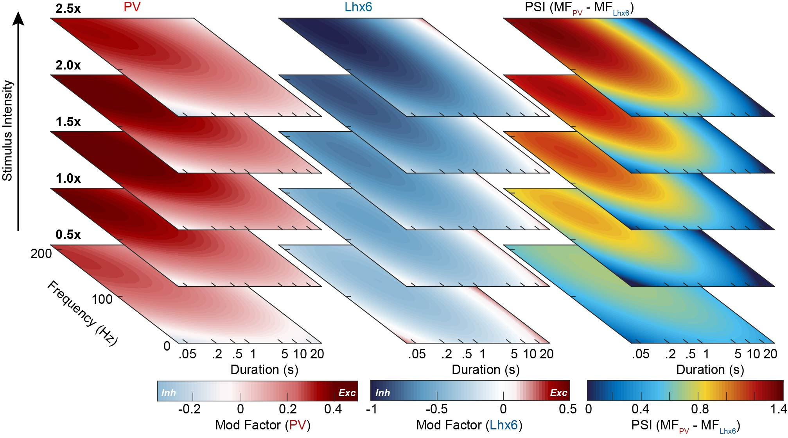

Fig. S2. Iterative modeling predicts short, high-frequency bursts will induce the greater separation in cell-type specific neuromodulation. Model-predicted changes in FR (Methods) for PV-GPe neurons (PV, left) and Lhx6-GPe neurons (Lhx6, middle) at indicated stimulus intensities (0.5x – 2.5x), generated using the first + second iteration of data collection. Throughout all surface plots, red = firing rates increase; blue = firing rates decrease. Right: Degree to which burst combinations are predicted to segregate the responses of PV-GPe and Lhx6-GPe populations as measured by a Population Separation Index (PSI) = MF_{PV} - MF_{Lhx6} for all possible burst combinations across stimulus intensities. In all columns, duration (x-axis) is represented on log2 scale.

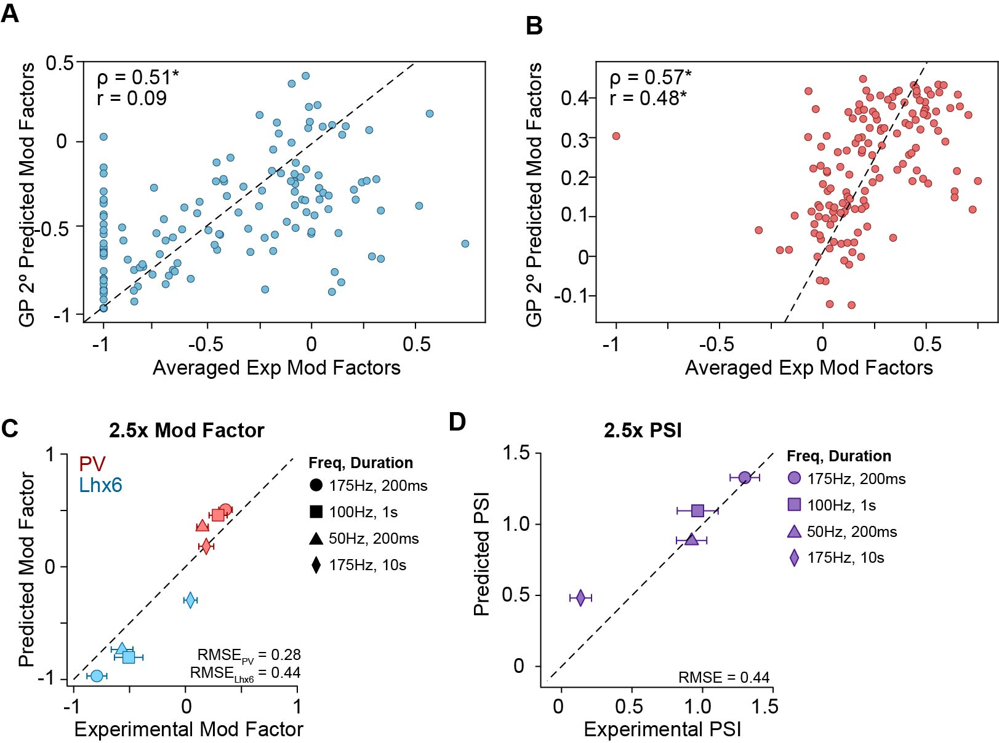

Fig. S3. Illustrations of model fit. (A-B) Model-predicted modulation factors for Lhx6-GPe (A) and PV-GPe (B) neurons (y-axis), vs. single-trial experimental data ( x-axis). Data are for stimulation amplitudes at 2.5x threshold intensity. A perfect fit would sit directly on the dashed line. Spearman and Pearson correlation coefficients are shown in the upper left corner for each cell type (Lhx6-GPe: ρ = 0.51, *p < 0.0001, r = 0.09, p = 0.29; PV-GPe: ρ = 0.57, *p < 0.0001, r = 0.48, *p < 0.0001). (C) Plots of model-predicted modulation factors for Lhx6-GPe and PV-GPe populations (y-axis) vs. experimentally-measured modulation factors (calculated from data shown in Fig. 2D-H, 5 trails, paired neurons). (D) Same as C, but values are shown for the population-segregation index (PSI). Calculated RMSE values are reported in the bottom right corner and detailed in Table S5.

Fig. S4. In vitro validation demonstrates translational suitability. (A) Validation shows 175 Hz/200ms burst stimulation results in similar modulation for monophasic stimulation (top) and biphasic stimulation (bottom) (3 Lhx6-GPe neurons, 4 PV-GPe neurons; 1 naïve mouse). (B) Validation shows 5 repeated trials of 175 Hz, 200ms burst stimulation in dopamine-depleted (DD) tissue drives differential modulation when the same neuron pairs are tested with translational biphasic stimulation (bottom) compared to monophasic stimulation (top). Translational biphasic stimulation slightly improves differential neuromodulation (PSI_{mono}: 1.0 ± 0.4, PSI_{bi}: 1.1 ± 0.5; Wilcoxon Signed Rank, *p = 0.02) (12 neuron pairs; 4 mice).

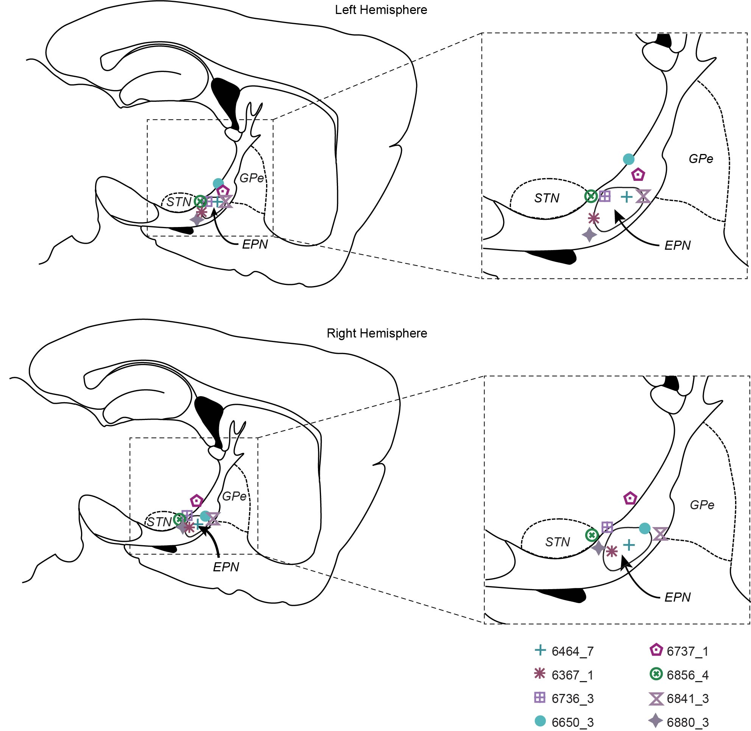
Fig. S5. Histologically verified electrode placements. Markers represent electrode placements near the EPN for all mice included in figure 4 for the left hemisphere (top) and right hemisphere (bottom). Symbols for placement in each mouse correspond with symbols used in Fig. 4.

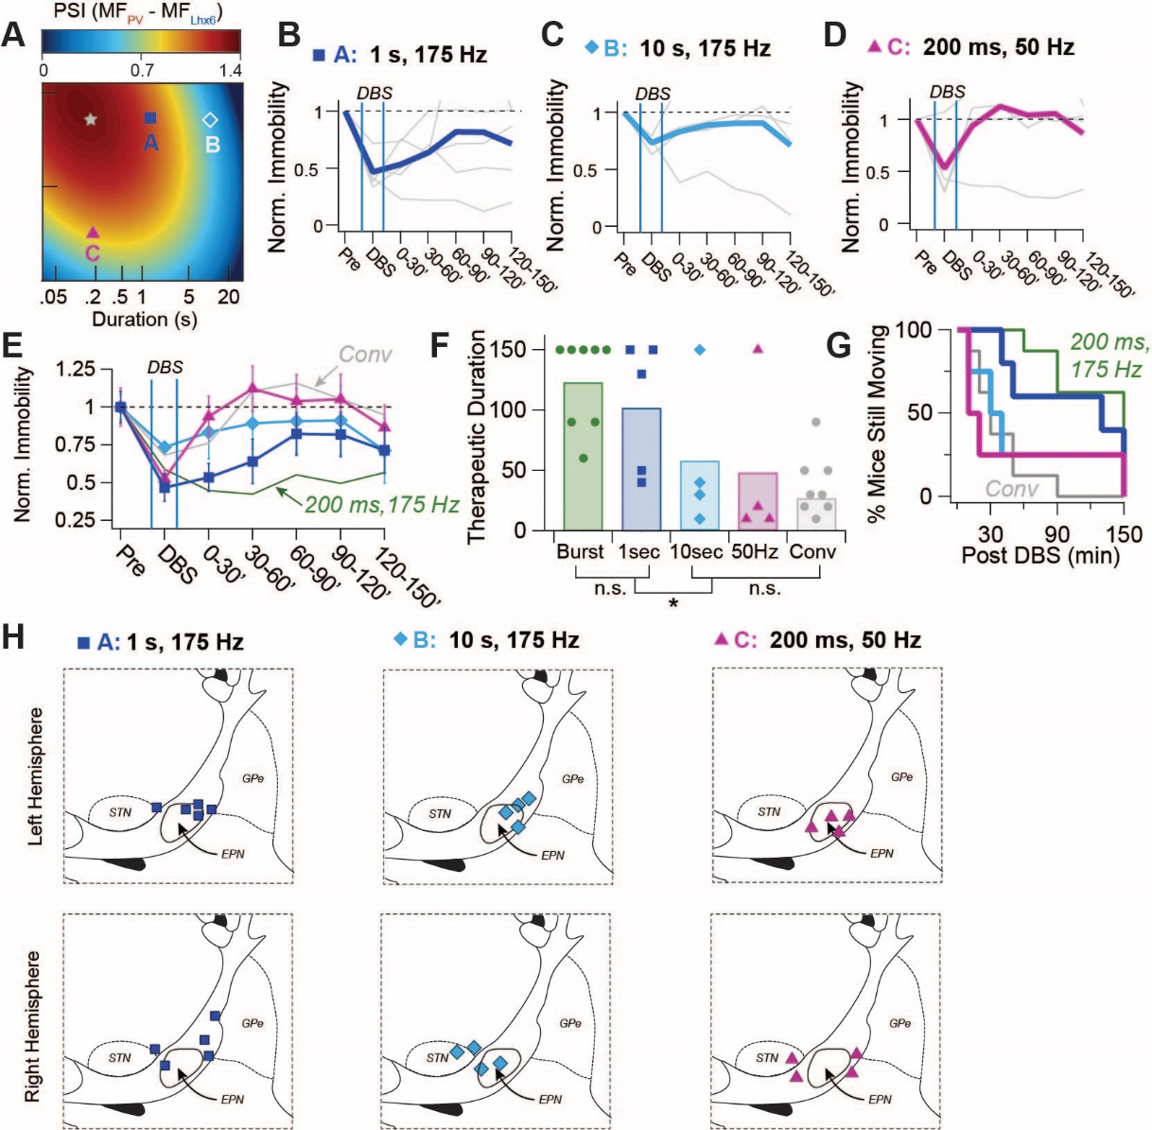
Figure S6: Projected population-specificity of burst protocols predicts therapeutic efficacy in vivo. (A) Surface plot from Fig. 2B, showing location of additional burst parameters tested (blue square =175 Hz/1 s every 5 s; teal diamond =175 Hz/10 s every 50 s; pink triangle = 50 Hz/200 ms, every 1). The star marks the location of the ‘optimal’ burst protocol, tested in Fig. 4 ( 175 Hz/ 200 ms, every 1 s ). (B - D) Normalized immobility plotted for the duration of behavioral trials. Thin gray lines, individual animals; thick colored lines, population averages, (B) 175 Hz/1 s: N = 5 mice; (C) 175 Hz/10 s: N = 4 mice; (D) 50 Hz/200 ms: N = 4 mice. (E) Overlay of averaged normalized immobilities for the 3 burst protocols, binned in 30 min intervals. Error bars, sem. For comparison, average normalized immobilities from conventional and burst DBS experiments (Fig. 4) are re-plotted in thin green (burst) or thin gray (conventional) lines. (F) Therapeutic durations for individual animals following the offset of stimulation for each DBS protocol. Symbols denote individual animals and filled bars are group averages. Compared to conventional DBS, therapeutic duration was significantly longer following 175 Hz/1 s DBS (104 ± 54.6 min, blue) (Mann-Whitney U, MWU, vs conv *p = 0.023), but not following 175 Hz/10 s DBS (57.5 ± 62.9 min, teal) (MWU, vs. conv, p = 0.804) or 50 Hz /200 ms DBS (47.5 ± 68.5 min, pink) (MWU, vs conv, p = 0.436). There was no significant difference in the therapeutic duration between 175 Hz/1 s and 175 Hz /200 ms (MWU, 1 s vs. 200 ms, p = 0.368). (F) Plot of the decay of therapeutic duration within groups of mice. (H) Electrode placements near the EPN for all mice included in figure S6 for the left hemisphere (top) and right hemisphere (bottom).

Table S1. Parameters included in iteration 1
Frequencies (Hz) | 10, 20, 50, 80, 100, 150, 200
Durations (ms) | 50, 100, 250, 500, 1000, 5000, 10000, 20000, 30000
Stimulus Intensity Multipliers | 0.5, 1.0, 1.25, 1.5, 2, 2.5

Table S2. Comparisons between models after first iteration of data collection
PV-GPe | Pearson correlation coefficient | Spearman correlation coefficient
Linear regression | 0.267 (p = 0.002) | 0.367 (p < 10⁻⁴)
Linear regression with interacting terms | 0.241 (p = 0.006) | 0.4 (p < 10⁻⁵)
1° Gaussian process regression | 0.267 (p = 0.002) | 0.367 (p < 10⁻⁵)
2° Gaussian process regression | 0.418 (p < 10⁻⁶) | 0.524 (p < 10⁻⁹)
Lhx6-GPe | Pearson coefficient | Spearman coefficient
Linear regression | 0.332 (p = 0.002) | 0.324 (p = 0.0003)
Linear regression with interacting terms | 0.308 (p = 0.006) | 0.325 (p = 0.0003)
1° Gaussian process regression | 0.332 (p = 0.002) | 0.324 (p = 0003)
2° Gaussian process regression | 0.4189 (p < 10⁻⁵) | 0.407 (p < 10⁻⁵)
Table S2: Models were assessed using leave-one-out cross-validation for data collected in iteration 1.

Table S3. Sampling rates for generating model predictions
Frequencies (Hz) | Every 5 Hz from 0 Hz through 200 Hz
Durations (ms) | Every 20 ms from 20 ms through 2500 ms; every 1000 ms from 3000 ms through 30000 ms
Stimulus Intensity Multipliers | Every 0.05x from 0.5x through 2.5x

Table S4. Values prioritized when generating data in iteration 2
Frequencies (Hz) | 125, 135, 140, 150, 175, 180, 200
Durations (ms) | 200, 225, 250, 275, 325, 350, 400, 1000, 4000
Stimulus Intensity Multipliers | 1.0, 1.75, 1.9, 2, 2.1, 2.15, 2.25, 2.4, 2.5

Table S5: Root Mean Squared Error Analysis (RMSE)
Duration | Freq (Hz) | Intensity |  | MF_{Lhx6} RMSE |  | MF_{PV} RMSE |  | PSI RMSE
200ms | 50 | 1x |  | 0.57 |  | 0.18 |  | 0.60
200ms | 175 | 1x |  | 0.72 |  | 0.30 |  | 0.88
1s | 100 | 1x |  | 0.71 |  | 0.28 |  | 0.83
10s | 175 | 1x |  | 0.21 |  | 0.18 |  | 0.29
ALL 1.0X |  |  |  | 0.59 |  | 0.24 |  | 0.69
200ms | 50 | 2.5x |  | 0.39 |  | 0.32 |  | 0.39
200ms | 175 | 2.5x |  | 0.37 |  | 0.33 |  | 0.38
1s | 100 | 2.5x |  | 0.55 |  | 0.28 |  | 0.54
10s | 175 | 2.5x |  | 0.41 |  | 0.18 |  | 0.44
ALL 2.5X |  |  |  | 0.44 |  | 0.28 |  | 0.44

Table S5: RMSE for model predictions vs. experimental validation data presented in Figure 2. Modulation Factors (MF) were calculated for each neuron, and PSIs were calculated for each neuron pair for validation experiments presented in Fig 2. Residuals between each neuron/neuron-pair and the model prediction were calculated for any given parameter combination, squared, and averaged across populations/conditions, and then square roots were calculated. RMSEs are presented for indicated parameter combinations, as well as calculated for all parameter combinations at 1.0x and 2.5x stimulus intensities.

Table S6: Statistical Metrics
Figure | Comparison | Groups | Statistical analysis
1C | Firing rate significantly modified from baseline during stimulation (gray symbols) | n = 24 neurons  N = 6 mice | Student’s t-test; 2 tailed, paired  19 neurons, p < 0.05  4 Lhx6 neurons, p > 0.05  1 PV neuron, p > 0.05
1C | PV-GPe vs Lhx6-GPe modulation factors | n = 12 neuron pairs  N = 6 mice | Mann Whitney U (Wilcoxon Ranked Sum)  p = 0.29
1D | comparing PV-GPe and Lh6-GPe I/E ratios across stimulation intensities | n = 15 neuron pairs  N = 5 mice | Kruskal Wallis across all stimulation intensities:  KW, χ²(7) = 57.4, p < 0.00001  Total N =215  Test Statistic = 57.380  Degree Of Freedom = 1  Asymptotic Sig. (2-sided test) = 0
1D | I/E ratio comparison at each intensity | n = 15 neuron pairs  N = 5 mice | Post-hoc pairwise Mann Whitney U; Bonferroni correction  Intensity p-value  0.1 0.509219  0.25 0.094221  0.5 0.013703  1 0.00003  2 0.000765  3 0.000421  4 0.00915  5 0.009556
1G | Lhx6-GPe vs PV-GPe IPSQ comparison in first second of stimulation | n = 10 neuron pairs  N = 4 mice | Mann Whitney U  p = 0.023
1I | PV-GPe modulation factor across all time bins | n = 14 neuron pairs  N = 3 mice | Kruskal Wallis across time bins  KW, χ²(2) = 9.6, p = 0.008  Independent-Samples Kruskal-Wallis Test Summary  Total N = 42  Test Statistic = 9.589  Degree Of Freedom = 2  Asymptotic Sig.(2-sided test) = 0.008  The test statistic is adjusted for ties.
1I | Lhx6-GPe modulation factor across all time bins | n = 14 neuron pairs  N = 3 mice | Kruskal Wallis across time bins  KW, χ²(2) = 7.9, p = 0.019  Independent-Samples Kruskal-Wallis Test Summary  Total N = 42  Test Statistic = 7.947a  Degree Of Freedom = 2  Asymptotic Sig.(2-sided test) = 0.019  The test statistic is adjusted for ties.
1I | PSI across all time bins | n = 14 neuron pairs  N = 3 mice | Kruskal Wallis across time bins  KW, χ2(2) = 12.0, p = 0.003  Independent-Samples Kruskal-Wallis Test Summary  Total N = 42  Test Statistic = 11.967  Degree Of Freedom = 2  Asymptotic Sig.(2-sided test) = 0.003  The test statistic is adjusted for ties.
1I | PSI bin comparison | n = 14 neuron pairs  N = 3 mice | Pairwise Comparisons of Bins  Samples Test Stat Std. Error Std. Test Stat Sig. Adj. Sig*  bin2-bin1 5.429 4.637 1.171 0.242 0.725  bin2-bin0 15.786 4.637 3.404 0.001 0.002  bin1-bin0 10.357 4.637 2.234 0.026 0.077  -Each row tests the null hypothesis that the Sample 1 and Sample 2 distributions are the same.  -Asymptotic significances (2-sided tests) are displayed. The significance level is .05.  *Significance values have been adjusted by the Bonferroni correction for multiple tests.
1K | Firing rate significantly modified from baseline during stimulation (gray symbols) | n = 28 neurons  N = 3 mice | Student’s t-test; 2 tailed, paired  19 neurons, p < 0.05  0 Lhx6 neurons, p > 0.05  1 PV neuron, p > 0.05
2B | Model results, 1st iteration | n = 19 neuron pairs  N = 5 mice | Leave-one-out Cross Validation Results  Lhx6-GPe Modulation Factors:  r = 0.42, p < 0.0001, ρ = 0.41, p < 0.0001  PV-GPe Modulation Factors:  r = 0.42, p < 0.0001, ρ = 0.52, p < 0.0001
2B | Model results, 2nd iteration | n = 27 neuron pairs  N = 8 mice | Leave-one-out Cross Validation Results  Lhx6-GPe Modulation Factors:  r = 0.09, p = 0.29, ρ = 0.51, p < 0.0001  PV-GPe Modulation Factors:  r = 0.48, p < 0.0001, ρ = 0.57, p < 0.0001
2D | Firing rate significantly modified from baseline during stimulation (gray symbols) | n = 28 neurons  N = 4 mice | Student’s t-test; 2 tailed, paired  22 neurons, p < 0.05  5 Lhx6 neurons, p > 0.05  1 PV neuron, p > 0.05
2E | Firing rate significantly modified from baseline during stimulation (gray symbols) | n = 28 neurons  N = 4 mice | Student’s t-test; 2 tailed, paired  18 neurons, p < 0.05  5 Lhx6 neurons, p > 0.05  5 PV neuron, p > 0.05
2F | Firing rate significantly modified from baseline during stimulation (gray symbols) | n = 28 neurons  N = 4 mice | Student’s t-test; 2 tailed, paired  24 neurons, p < 0.05  2 Lhx6 neurons, p > 0.05  2 PV neuron, p > 0.05
2G | Firing rate significantly modified from baseline during stimulation (gray symbols) | n = 28 neurons  N = 4 mice | Student’s t-test; 2 tailed, paired  20 neurons, p < 0.05  7 Lhx6 neurons, p > 0.05  1 PV neuron, p > 0.05
2H | Firing rate significantly modified from baseline during stimulation (gray symbols) | n = 28 neurons  N = 4 mice | Student’s t-test; 2 tailed, paired  22 neurons, p < 0.05  5 Lhx6 neurons, p > 0.05  1 PV neuron, p > 0.05
3A | Firing rate significantly modified from baseline during stimulation (gray symbols) | n = 34 neurons  N = 3 mice | Student’s t-test; 2 tailed, paired  31 neurons, p < 0.05  3 Lhx6 neurons, p > 0.05  0 PV neuron, p > 0.05
3B | Firing rate significantly modified from baseline during stimulation (gray symbols) | n = 32 neurons  N = 2 mice | Student’s t-test; 2 tailed, paired  32 neurons, p < 0.05
3D | Firing rate significantly modified from baseline during stimulation (gray symbols) | n = 54 neurons  N = 4 | Student’s t-test; 2 tailed, paired  37 neurons, p < 0.05  0 Lhx6 neurons, p > 0.05  17 PV neuron, p > 0.05
3F | Antagonist wash-in significantly modifies modulation factor | n = 4 PV-GPe neurons; 5 Lhx6-GPe neurons  N = 2 mice | Student’s t-test; 2 tailed, paired  PV-GPe, control vs APV/NBQX wash in: p = 0.0001  Lhx6-GPe, control vs APV/NBQX wash in: p = 0.18
3F | Firing rate significantly modified from baseline during stimulation (gray symbols) | n = 4 PV-GPe neurons; 5 Lhx6-GPe neurons  N = 2 mice | Student’s t-test; 2 tailed, paired  Control  9 neurons, p < 0.05 (all neurons significantly modified)  APV/NBQX wash in  6 neurons, p < 0.05  0 Lhx6 neurons, p > 0.05  3 PV neuron, p > 0.05
3G | Firing rate significantly modified from baseline during stimulation (gray symbols) | n = 8 PV-GPe neurons; 10 Lhx6-GPe neurons  N = 5 mice | Student’s t-test; 2 tailed, paired  Control  17 neurons, p < 0.05  1 Lhx6 neuron, p > 0.05  0 PV neurons, p > 0.05  CNO wash in  18 neurons, p < 0.05 (all neurons significantly modified)
4D | Locomotion  Conv vs Bursts | N=8 mice | Wilcoxon Signed Rank  Conv  pre vs stim, p = 0.055  stim vs 90’ p = 0.008  pre vs. 90’ p = 0.195  Burst  pre vs stim p =0.016  stim vs 90’ p = 0.195  pre vs. 90’ p = 0.008
4E | Immobility  Conv vs Bursts | N=8 mice | Wilcoxon Signed Rank  Conv  pre vs stim, p = 0.056  stim vs 90’ p = 0.008  pre vs 90’ = 0.195  Burst  pre vs stim, p = 0.016  stim vs 90’, p = 0.641  pre vs. 90’ = 0.016
4I | Therapeutic duration | N=8 mice | Wilcoxon Signed Rank  Conv vs. Burst p = 0.012
Supplemental Figures
S1B | EPSCs across all stimulus intensities | n = 15 neuron pairs  N = 5 mice | Independent-Samples Kruskal-Wallis Test Summary  Total N = 225  Test Statistic = 44.358  Degree Of Freedom = 1  Asymptotic Sig.(2-sided test) p = 0
S1B | EPSCs comparison at each intensity | n = 15 neuron pairs  N = 5 mice | Post-hoc pairwise Mann Whitney U p-values; Bonferroni correction  Amp p value  0.1 0.048555  0.25 0.000341  0.5 0.000794  1 0.000629  2 0.000421  3 0.000276  4 0.010699  5 0.025666
S1C | IPSCs across all stimulus intensities | n = 15 neuron pairs  N = 5 mice | Independent-Samples Kruskal-Wallis Test Summary  Total N = 233  Test Statistic = 8.448  Degree Of Freedom = 1  Asymptotic Sig.(2-sided test) p = 0.004
S1D | IPSC comparison at each intensity | n = 15 neuron pairs  N = 5 mice | Post-hoc pairwise Mann Whitney U p-values; Bonferroni correction  Amp p value  0.1 0.325821  0.25 0.523487  0.5 0.324915  1 0.016093  2 0.187268  3 0.040840  4 0.035045  5 0.090847
S3A | Model results, 2nd iteration | n = 27 neuron pairs  N = 8 mice | Leave-one-out Cross Validation Results  Lhx6-GPe Modulation Factors:  r = 0.09, p = 0.29, ρ = 0.51, p < 0.0001
S3B | Model results, 2nd iteration | n = 27 neuron pairs  N = 8 mice | Leave-one-out Cross Validation Results  PV-GPe Modulation Factors:  r = 0.48, p < 0.0001, ρ = 0.57, p < 0.0001
S4B | PSIs from monophasic vs biphasic stimulation | n = 12 neuron pairs  N = 4 mice | Wilcoxon Signed Rank  Monophasic vs Biphasic  p = 0.0232
S4B | Firing rate significantly modified from baseline during stimulation (gray symbols) | n = 24 neurons  N = 4 mice | Student’s t-test; 2 tailed, paired  Monophasic  22 neurons, p < 0.05  0 Lhx6 neurons, p > 0.05  2 PV neuron, p > 0.05  Biphasic  21 neurons, p < 0.05  1 Lhx6 neurons, p > 0.05  2 PV neuron, p > 0.05
S6F (4I) | Therapeutic duration  Conv vs 175Hz/ 200msec DBS | N=8 mice | Wilcoxon Signed Rank (paired), p=0.012
S6F | Therapeutic duration  Conv vs 175Hz/1sec DBS | N=5 mice | Mann-Whitney U (unpaired), p=0.023
S6F | Therapeutic duration  175Hz/200 msec vs 175Hz/1sec DBS | N=5 mice | Mann-Whitney U (unpaired), p=0.368
S6F | Therapeutic duration  Conv vs 175Hz/10sec DBS | N=4 mice | Mann-Whitney U (unpaired), p=0.804
S6F | Therapeutic duration  Conv vs 50Hz/200 msec DBS | N=4 mice | Mann-Whitney U (unpaired), p=0.436

Movie S1. Side-by-side top view comparison of conventional and burst stimulation in the same mouse showing increased therapeutic duration with bursts.

Movie S2. Side view of mouse behavior before, during, and after burst stimulation.

References:
29. C. Yu, I. R. Cassar, J. Sambangi, W. M. Grill, Frequency-Specific Optogenetic Deep Brain Stimulation of Subthalamic Nucleus Improves Parkinsonian Motor Behaviors. J Neurosci. 22, 4323-4334 (2020).
30. A. V Kravitz, B. S. Freeze, P. R. Parker, K. Kay, M. T. Thwin, K. Deisseroth, A. C. Kreitzer, Regulation of parkinsonian motor behaviours by optogenetic control of basal ganglia circuitry. Nature. 466, 622–626 (2010).
31. K. J. Mastro, R. S. Bouchard, H. A. K. Holt, A. H. Gittis, J. Neurosci. 34, 2087 (2014).
32. D. T. Brocker, B. D. Swan, R. Q. So, D. A. Turner, R. E. Gross, W. M. Grill, Optimized temporal pattern of brain stimulation designed by computational evolution. Sci. Transl. Med. 9, eaah3532 (2017).
33. A. Karatzoglou, K. Hornik, A. Smola, A. Zeileis, kernlab - An S4 package for kernel methods in R. J. Stat. Softw. 11, 1–20 (2004).

